Assignment 6 Dillards & Sams Club Data by Joshua Troup

What was the COST of the items sold in the Fayetteville store of Dillard’s?

**$3,070,446.75**

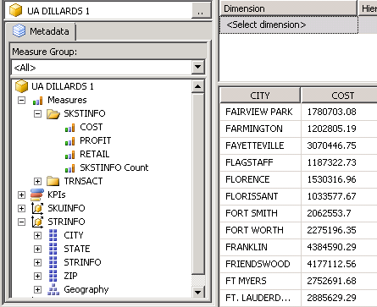

What is the AMT (amount) of items sold at Little Rock stores?

**$25,469,923.01**

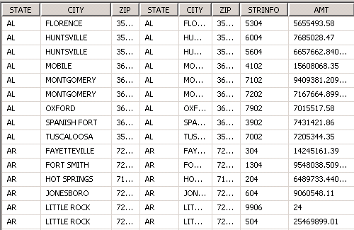

What is the amount of items sold in the Fayetteville store in Quarter 3 of the year 2004?

**$1,896,980.34**

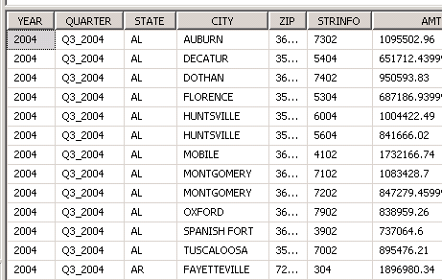

The AMT of the items sold in Fayetteville store in Quarter 3 of 2004 … BRAND Calvin

K is only **$14,765.47**

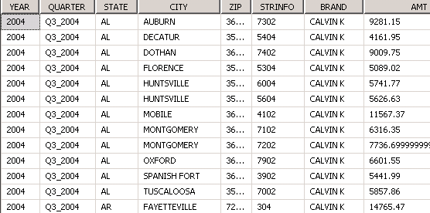

Add a Profit Margin calculation to the cube. (Fayetteville)

**18.79%**

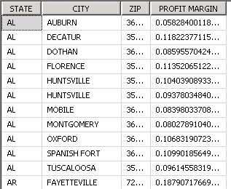

Profit Margin calculation to the cube. (Fayetteville) (Calvin Klein)

**29.46%**

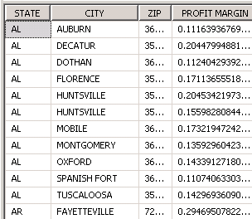

KPI



Partitioning

**2004-46,103,710 rows**

**2005-74,813,187 rows**

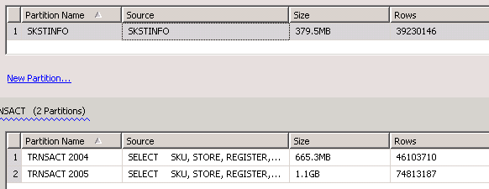

What was the Total Scan Amount of the items sold in the Dallas, TX stores of Sam’s Club?

**3,652,925.70**

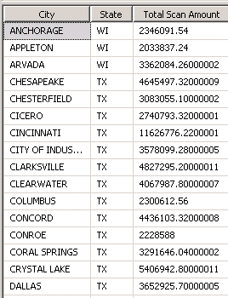

What was the Total Scan Amount of the items sold in the Columbus, TX stores of Sam’s Club?

**2,300,612.56**